**Set of 3 Golden Dragons Metal Wall Art**

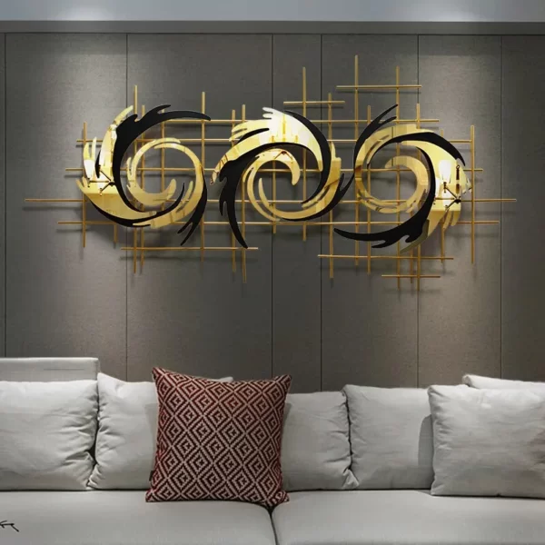A set of 3 golden dragons metal wall art is a breathtaking decor ensemble that embodies strength, elegance, and cultural symbolism. Each panel showcases a majestic dragon in a flowing, dynamic pose, intricately crafted from metal and finished in a luxurious golden tone. The shimmering metallic surface adds a touch of opulence, while the dragons’ detailed designs convey power and movement. Perfect for living rooms, dining spaces, or offices, this trio makes a commanding statement as a unified display or when arranged separately. Steeped in tradition and artistry, this wall art set brings an aura of prosperity and sophistication to any interior.